Table Ⅰ: Theoretical Dimensions and Key Concepts in AI and Higher Education
Framework | Dimension | Definition | Canonical Sources | Representative Educational Applications | Keywords / Topic Terms
Role Conflict Theory (RCT) | Role Conflict | Role Conflict is the incompatibility of demands from different roles or expectations that an individual must fulfill. | (Kahn et al., 1964) ;  (Katz, 1978) | (Buele & Llerena-Aguirre, 2025) | Efficiency, workload, assessment integrity, accountability
 | Role Ambiguity | Role Ambiguity occurs when expectations or responsibilities are unclear, causing confusion about what is required. | (Rizzo et al., 1970) | (Chan, 2023);  (Wu et al., 2024) | Policy clarity, transparency, authorship, and AI ethics
 | Role Overload | Role Overload is the condition where the demands of roles exceed an individual's ability to meet them, leading to burnout. | (Kahn et al., 1964)  (Acosta-Enriquez et al., 2025) | (Buda & Kovács, 2024) | Burnout, digital surveillance, compliance, and emotional fatigue
Human Function Theory (HFT) | Qualification | Qualification focuses on providing knowledge, skills, and competencies to enable individuals to "do something." | (Biesta, 2021; Biesta, 2015) | (Crompton & Burke, 2023) | Competence, performance, optimization, adaptive feedback
 | Socialization | Socialization is the process of integrating individuals into existing social, cultural, and political systems. | (Biesta, 2021; Biesta, 2015) | (Ghimire & Edwards, 2024; Leopold, 2024) | Community, integrity, shared values, collaboration
 | Subjectification | Subjectification refers to the process of becoming an autonomous subject, independent of existing structures, thereby fostering freedom and agency. | (Biesta, 2021; Biesta, 2015); | (Smith & Vickers, 2024) | Agency, authorship, identity, autonomy, moral judgment
Source: Author’s elaboration
Data Sources and Search Strategy
Given the broad scope of research on AI technology and higher education, this study's dataset was compiled from two leading academic databases, Scopus and Web of Science (WoS), to ensure the corpus's authority. To ensure the relevance of search results to this research, keyword combinations such as "artificial intelligence," "machine learning," "deep learning," "AI ethics," "higher education," "university teaching," and "academic management" were used for retrieval. The initial search yielded 6,350 records (Scops = 4,460; WoS = 1,890), from 2000 to 2025, covering both the pre-AI and generative AI stages of academic development. Table 2 shows the detailed keyword scheme.
Table2. Keyword Variables and Search Strategy
VARIABLES | KEYWORDS
AI Technologies | "Artificial Intelligence" or "AI" or "machine learning" or "generative AI" or "ChatGPT"
Education Scope | "Higher education" or "university" or "college" or "tertiary education"
Teaching & Learning Context | "ethics" or "trust" or "anxiety" or "role conflict" or "identity" or "relationship" or "emotional" or "sustainability" or "humanity" or "authenticity"

Next, a four-stage screening process was conducted in Data cleaning and integration:
- Identification: Raw metadata were exported in standardized formats (WoS Plain Text and Scopus CSV).
- Screening: Duplicate and incomplete records were removed by DOI matching and title-year cross-checking, producing 4,294 unique entries.
- Eligibility: Records lacking valid titles, abstracts, or publication years were excluded; disciplinary filters ensured that only higher-education–related works remained.
- Inclusion: 4,280 publications were retained for analysis after final validation, as summarized in the PRISMA flow diagram (Figure 1).
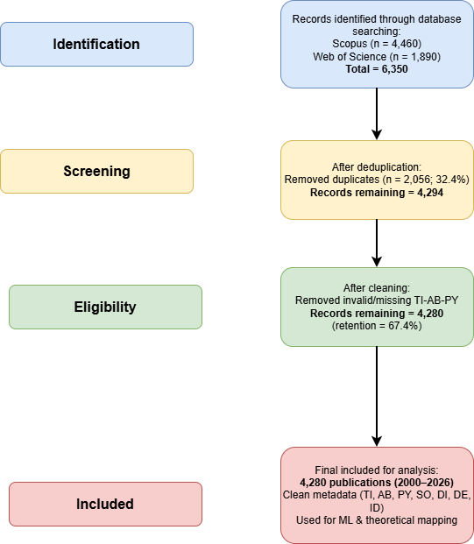
Figure 1. Data collection and cleaning flow diagram.
Source: Author’s elaboration
To turn the conceptual framework outlined in Chapter 2 into measurable variables for analysis, we translated each dimension of Role Conflict Theory (RCT) and Human Functioning Theory (HFT) into explicit semantic representations. Table 3 summarizes how these six theoretical dimensions were broken down and the key terms used to represent them. This step connects the ideas of efficiency and humanity with the computational methods explained in Section 3.2, ensuring that the analysis is grounded in real data and supported by solid theoretical understanding.
Table 3. Operationalization of Theoretical Dimensions and Lexical Sources
Dimension | Lexical Sources | Representative Keywords from the corpus | Semantic Encoding Rule | Computational Role
RCT – Role Conflict | (Kahn et al., 1964; Katz, 1978);  (Rizzo et al., 1970) | assessment, integrity, accountability, fairness, grading, policy tension | SBERT cosine similarity between document vector and dimension centroid (keyword set) | Indicator of efficiency-related institutional tension (used in topic–theory matrix)
RCT – Role Ambiguity | (Rizzo et al., 1970); Chan et al., 2023; Wu et al., 2024; corpus | policy, policies, authorship, boundaries, uncertainty, transparency | Same as above | Captures uncertainty about appropriate AI use and unclear responsibilities
RCT – Role Overload | (Kahn et al., 1964); (Acosta-Enriquez et al., 2025); (Buda & Kovács, 2024) | workload, burnout, surveillance, compliance, always-on, reporting | Same as above | Measures digital/administrative burden associated with AI-enabled work
HFT – Qualification | (Biesta, 2010, 2021) | skills, competence, personalization, feedback, measurement, performance | Same as above | Proxy for efficiency-oriented learning outcomes and optimization logics
HFT – Socialization | (Biesta, 2010, 2021) (Ghimire & Edwards, 2024); (Leopold, 2024) | community, collaboration, participation, norms, integrity, culture | Same as above | Signals the formation of communities of practice and academic-integrity cultures
HFT – Subjectification | (Biesta, 2010, 2021); (Kristjánsson, 2015); (Smith & Vickers, 2024) | autonomy, agency, authorship, identity, reflection, judgment | Same as above | Marker of human flourishing: authorship, moral agency, self-formation
Note: The topic–theory mapping data underlying Table 3 are available as Supplementary File S1 (“AI_HE_with_TheoryBucket6_multi.xlsx”), including the fields topic, TheoryBucket6, and TheoryBucket6_multi covering topics T00–T11. We combined canonical theory terms with frequent corpus expressions for each dimension to form a centroidal keyword set. Documents were encoded using cosine similarity (Sentence-BERT), resulting in the 12 × 6 topic–theory matrix presented in Section 3.2.
For each of the six theoretical dimensions—conflict, ambiguity, overload, qualification, socialization, and subjectification—we compiled a set of representative keywords from three sources:
Canonical literature (Biesta, 2010, 2021; Kahn et al., 1964; Rizzo et al., 1970) to maintain conceptual integrity.
Recent higher-education studies that apply RCT or HFT in digital and AI-mediated contexts (Ghimire & Edwards, 2024; Leopold, 2024; Smith & Vickers, 2024).
Data-driven term expansion using word-embedding similarity within the cleaned corpus to capture modern linguistic variants (e.g., "automation," "teacher workload," "student agency").
Detailed keyword lists and coding rules are provided in Supplementary File S2 (Updated Coding Manual with Mapping Rules.docx).
We reviewed all the lexicons for semantic distinctiveness and overlap, ensuring each dimension represented a unique yet complementary aspect of educational discourse. The finalized lexicon contained approximately 120 terms, balanced across the six dimensions. The reliability between encoders was evaluated using Krippendorff and Cohen's κ to ensure consistency in the plotting process. This step is crucial for validating the reliability of expert judgment and ensuring a robust theoretical framework (krippendorff, 2004). According to Landis & Koch (1977), a Cohen’s κ (or Krippendorff’s α) above 0.80 indicates almost perfect agreement (Landis & Koch, 1977). Our expert coding achieved κ = 0.898 and α = 0.889, demonstrating high consistency, visualized in Figure 3. Full expert judgments are available in Supplementary File S3 (Expert Mapping_with_Bucket6_multi.xlsx).
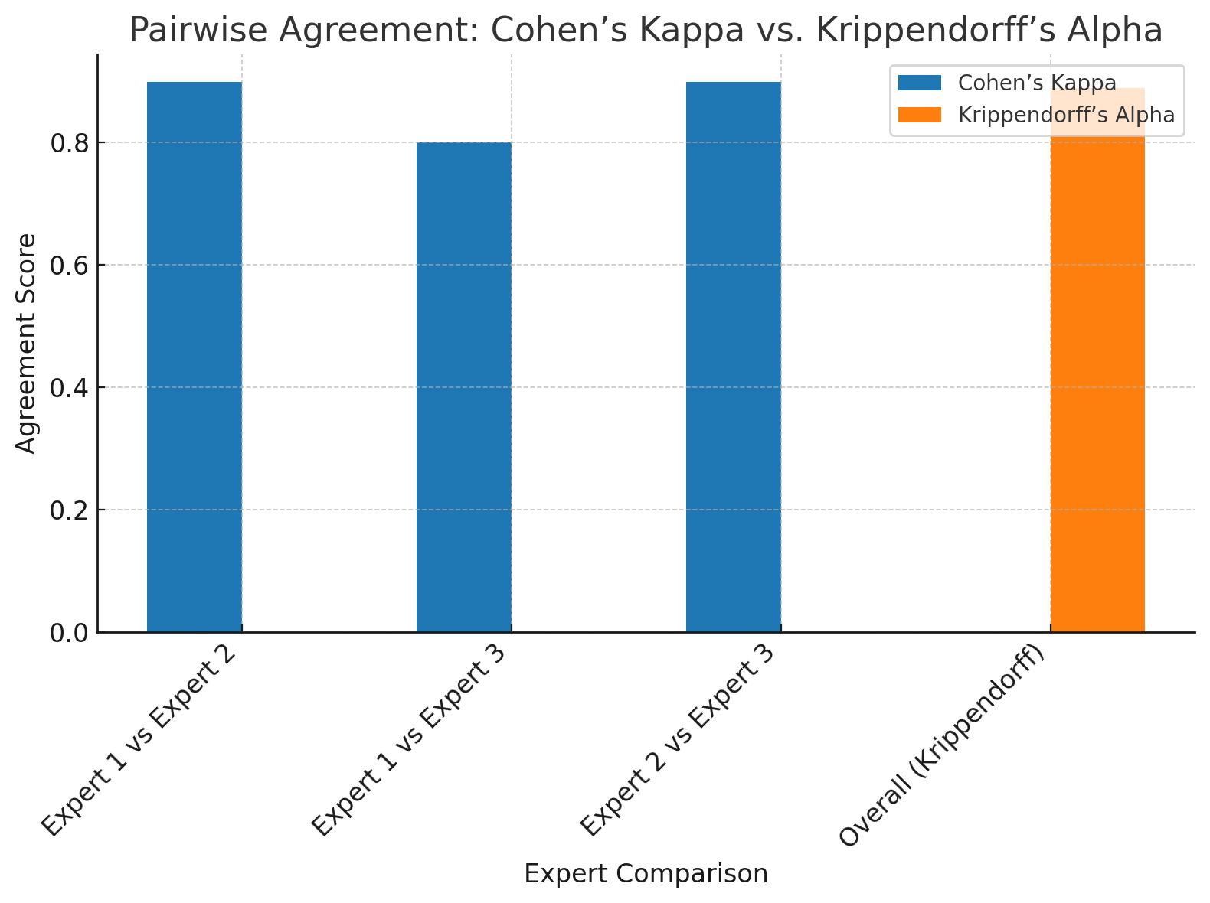
Figure 3. Inter-coder Reliability for Bucket-6 Mapping.
Source: Author’s elaboration
The author's publication titles and abstracts were converted into numerical features using Sentence-BERT embeddings. We calculated the cosine similarity for each text vector to the centroids of the six theoretical lexicons. The resulting similarity scores, ranging from 0 to 1, serve as continuous indicators of how well the document aligns with each theoretical dimension. Higher values mean that the document's content more closely matches a specific theoretical dimension. These scores were then grouped by topic clusters (Section 3.2) to create the 12 × 6 topic-theory matrix for correspondence and time-series analyses. The matrix and related data are available in Supplementary File S1 (AI_HE_with_TheoryBucket6_multi.xlsx).
In this design, this study combines theoretical foundations with computer analysis to explore how the ethical governance of artificial intelligence affects the balance between efficiency and humanistic care in academic research discourse in higher education. The RCT dimension (conflict, ambiguity, overload) reflects the efficiency logic in education, expressed through semantics at management, accountability, and systemic pressure levels. On the other hand, the HFT dimension (qualification, socialization, subjectification) embodies the humanistic function of education, emphasizing growth, belonging, and autonomy.

